B.Com-I
(2016-17) 1st Semester Results
10 out of 10 Grade Points
S.No | Students Name | Subjects | Photo
1 | A.KAVYA | English  Sanskrit  Business Economics  Environmental Studies  Information Technology | 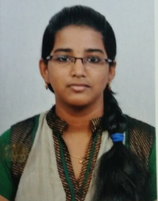
2 | B.ROOPA | English  Sanskrit  Financial Accounting  Business Organization | 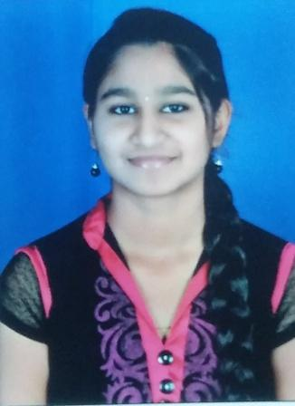
3 | CH.ALEKYA | English  Sanskrit  Business Economics  Financial Accounting | 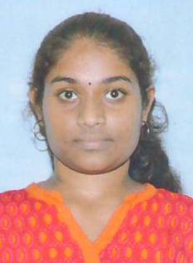
4 | G.VEENA | English  Sanskrit  Financial Accounting | 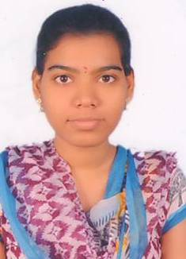

5 | R.HARSHITA | Sanskrit  Business Economics  Financial Accounting | 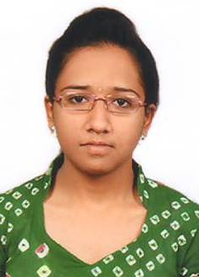
6 | S.VINOD AKHIL | Sanskrit  Business Economics  Environmental Studies  Financial Accounting  Business Organization | 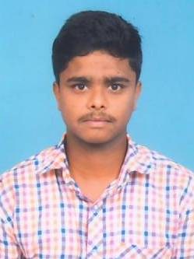
7 | V.SRI SANDHYA | Sanskrit  Financial Accounting | 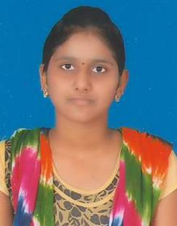
8 | N.RAJU | Environmental Studies  Business Organization | 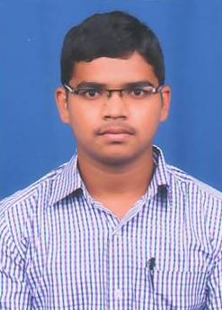
9 | C.NIRMALA | Telugu | 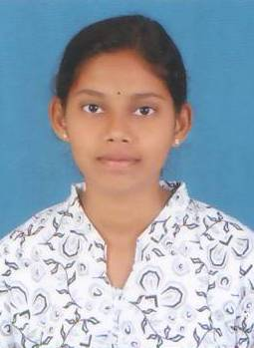

10 | P.MANASA | Financial Accounting | 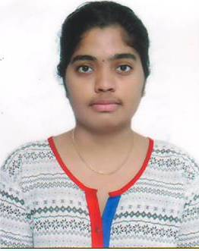
11 | SHREYA | Financial Accounting | 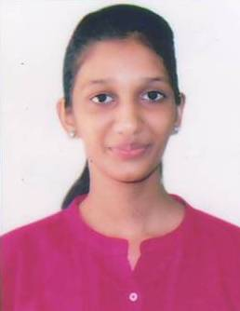
12 | R.GANESH SWAMY | Business Organization | 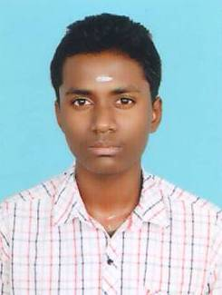
13 | VIKRAM | Financial Accounting | 