B.Sc-I
(2016-17) 1st Semester Results
10 out of 10 Grade Points
S.No | Student Name | Subjects | Photo
1 | N.SANDHYA | English  Telugu  Environmental | 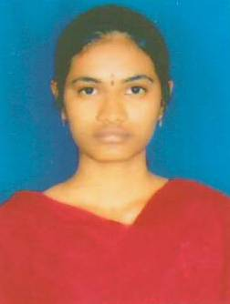
2 | P.SIRISHA | English | 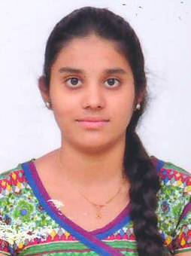
3 | V.MUNNIR BARKAT | Hindi | 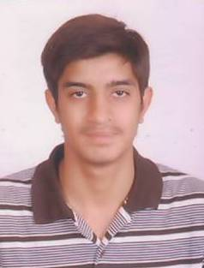
4 | VIJAY YADAV | Hindi | 